**Name**: polaroidme.yolasite.com

**Type of the Website**: Generic website

**Number of Pages**: 3

1. Content on Page 1:

* Name: Polaroid.
* It has the basic introduction of the website as the name suggest Polaroid.
* It has an “Try IT!” Button which, when clicked, will take the user to the next page (About Me).
* Apart from that, it has a “form_typing” form and a “form_submit” button which was in the project milestones which, when typed or clicked, will trigger an event which would be tracked by the in Google Analytics.

1. Content on Page 2:

* Name: About Me
* This page shows the photograph of a BB-8 bot form the Star Wars that has helped and developed the website. And bellow that there is an event triggering “Hyperlink” which is linked to the portfolio of the developer.
* Also, it has a “Download” link which will download a small image of the BB-2 bot as a surprise from the Bot. More than half of the users who landed on the page clicked the downloadable format link.

1. Content on Page 3:

* Name: Contact Us Page.
* The user will find different ways to contact me for commenting and to know more about the website.
* The page also contains the exact location of the develops office location for future business purposes.
* Separate buttons are placed below to submit the Name, Email, Phone, and a custom message by the user with a CAPTCHA that protects websites against bots by generating and grading tests.

1. Some Overview and additional insights about the Paths and Traffic Sources:

* As the website add was shared locally in the region the major traffic was from the local city and few other countries like India, Kuwait and Germany which were part of the analysis.
* People spent most of the time on the index page which is the About Me page to read and know about the developer.
* Most of the users used Chrome as their web browser to interact with the site, in which 57 users accessed the website using chrome desktop and 20 users from their mobile phones.
* Through the Behavioral events overview the users who downloaded can be seen as a potential people to click the hyperlink and vice versa.
* There were a smaller number of users attracted to the target Polaroid page and a greater number of users who exited or dropped the page which can be evaluated through the funnel visualization. Hence, I can conclude from these numbers that I need to do something about the website design, placement, marketing strategy, and add more of strategical ideas toward the target page to try and increase the number of users.

**Analysis**

1. **Site Traffic:**

* Three Projections have been made for the Visitors.
  1. **Baseline Projection**:
* This projection shows the actual numbers for the first month and projected numbers for month 2 and month 3.
* For the baseline model, I assumed that my new visitors would increase by 10% per month, I would lose 20% of repeat visitors each month and 15% of non-bounced new visitors would be retained as returning visitors.
* A 2-d graph has been made to visualize these numbers.
* Chart

  Description automatically generatedWe can clearly observe that the difference between new visitors and returning visitors very high.
  1. **Optimistic Projection**:
* This projection shows the actual numbers for the first month with an overly positive predictions for month 2 and month 3.
* Here, I assumed that my new visitors would increase by 15% per month, I would lose only 10% of repeat visitors each month and 25% of non-bounced new visitors would be retained as returning visitors.

* 1. **Pessimistic Projection**:
* This projection shows actual numbers for the first month and positive, yet achievable projections for month 2 and month 3.
* Chart, bar chart

  Description automatically generatedI assumed that my new visitors would increase by only 5% per month, I would lose only 30% of repeat visitors per month and 10% of non-bounced new visitors would be retained as returning visitors.
  1. **Summarized Forecasting Model:**
* Graphical user interface

  Description automatically generated with medium confidenceWith this we can see the clear distinction between the above explained three Forecasting model and their comparison amongst each of them.

* All these projections are made so that BB-8 can work around the website to make it better and attract more people towards it by observing what is working and what is not working for the visitors.
* General idea about these projections is that the goal is to reach the Optimistic Projection range and not go below the Pessimistic Projection data.
* This will ensure that my website will have comfortable, yet positive sources of traffic which can be increased in the sales and future of the company with the help of these projections and predictions.

1. **Monetization Overview**:

* These are the basic projections of my website with the visitor traffic from the previous model.
* This gives information about the estimated worth of the website after assigning certain monetized values to my goals and funnels with per determined criteria’s.
* As per this website, there are 5 goals which have been set. Visitors, Sessions, Pageviews, File Downloads and Form Submissions and one where three-page funnel completion is be checked.

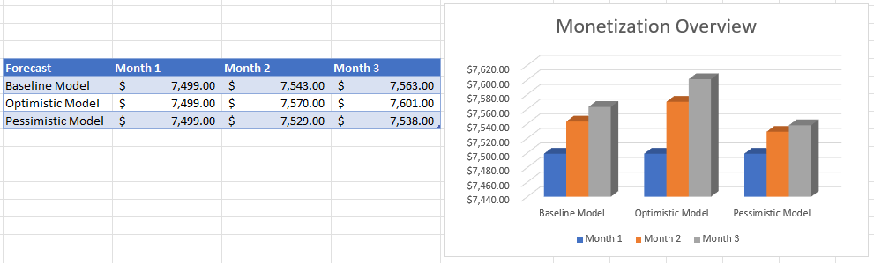

* It is very evident that there is a moderate difference between the Monetization Overview for Baseline Model and Optimistic Model.
* Also, there is not much between the Baseline and Pessimistic Models.
* The monetization values for the visitors have been made based on the projections for visits, events and goals counts with the given criteria.